**ASSESSMENT**

**NAME: Shayli Patel**

Python and MySQL

assessment test 2 hours

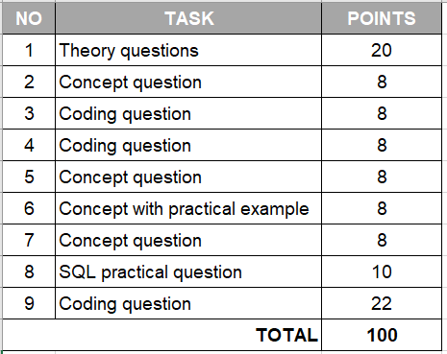

|  |  |
| --- | --- |
| 1. **Python theory questions** | **10 points** |

1. What is the program?

It is a set of instructions that are run by a computer.

1. What is the process?

It is a program in execution.

1. What is Cache?

It is a small amount of memory which is part of the Central Processing Unit (CPU) and temporarily holds data and instructions that can be reused.

1. What is Thread and Multithreading?

A thread is a single sequential flow of execution.

Multithreading is a CPU feature that allows two or more instruction threads to execute independently while sharing the same process resources.

1. What is GIL in Python and how does it work?

Global Interpreter Lock is a lock that allows one thread to hold the control of the interpreter and stay at a state of execution at a time.

1. What is Concurrency and Parallelism and what are the differences?

Concurrency is used for multi-threading and alternates back and forth between different programmes. This uses overall less computational power but takes longer to run.

Parallelism is when it is broken down into smaller tasks which are then processed at the same time ( or in parallel). This uses more computational power to process the smaller tasks simultaneously but tasks a shorter amount of time to execute.

1. What do these stand for in programming: DRY, KISS, BDUF

DRY - Don’t Repeat Yourself

KISS - Keep It Simple , Stupid

BDUF - Big Design Up Front

1. What is Garbage collector? How does it work?

The garbage collector keeps track of all objects in memory.

1. What are ‘deadlock’ and ‘livelock’ in a relational database?

A deadlock is essentially a lock that leads to a dead end and occurs when two or more tasks permanently block each other.

A Livelock is where a request for exclusive lock is denied continuously.

1. What is Flask and what can we use it for?

Flask is a lightweight Python web framework which can be used for creating web applications. Flask is easy to use and can be easily scaled up.

|  |  |
| --- | --- |
| 1. **Discuss the difference between Python 2 and Python 3** | **8 points** |

* Division operator - in Python 2, the output would be rounded into an integer, whereas in Python 3, a decimal would remain a float.
* String - in Python 2, print was a keyword, whereas in Python 3 print() is a function and requires brackets.
* String type (Unicode/ASCII) - In Python 2, a string type is ASCII, whereas in Python 3, a string type is Unicode.
* xrange - xrange of Python 2 doesn’t exist in Python 3.

|  |  |
| --- | --- |
| 1. **Write a function that can define whether a word is a Palindrome or not (a word, phrase, or sequence that reads the same backwards as forwards, e.g. *madam*)** | **8 points** |

In Assessment_2.py file

|  |  |
| --- | --- |
| 1. **Write tests for the newly created Palindrome function. Provide a brief explanation for your test case options.** | **8 points** |

In Assessment_2.py file

|  |  |
| --- | --- |
| 1. **Agile methodology, Scrum: name at least 3 types of meetings that are exercised by Agile teams and describe the objective of each meeting.**  * Daily scrum - usually 15 minutes and held at the same time every day for the Developers to focus on the scrum goal. Developers discuss what they have worked on that day/previous day and what they are planning on working on to meet the scrum goal. This is held by the Scrum master. * Sprint Planning - this meeting kicks off the sprint. In this meeting, the delivery outcomes of the sprint will be defined and a plan on how that work will be achieved. * Sprint review - this is the second to last event of the sprint where the results of the sprint are presented and the scrum team and stakeholders discuss what was achieved and accomplished. | **8 points** |

|  |  |
| --- | --- |
| 1. **Exception handling in Python, explain what each of the following blocks means in the program flow:**   The try, except, else, finally exception handling method is used to execute code without it quitting the code if an error is encountered. Instead, when an error is encountered, the exception code is executed instead.  Try - runs the code  Except - when an exception is raised, use this code  Else - if no exceptions, run this code  Finally **-** code will always run, no matter if exception is raised. | **8 points** |

|  |  |
| --- | --- |
| 1. **How can we connect a Python program (process) with a database? Explain how it works and how do we fetch / insert data into DB tables from a python program.**  * We connect python to SQL database using the mysql.connector library that needs to be imported. * Create a connection importing the username, password and host details from a separate file (done for security purposes). * Create new cursor using cursor() method. * Then create a variable with the SQL statement in three sets of quotation marks ( “”“SELECT….. “””) * Then can use fetchall statement to put the data into a tuple or can execute an insert statement in the SQL query statement to insert data. * Then close the cursor and the connection | **8 points** |

|  |  |
| --- | --- |
| 1. **Given two SQL tables below: authors and books.**  * **The authors dataset has 1M+ rows** * **The books dataset also has 1M+ rows**   Create an SQL query that shows the TOP 3 authors who sold the most books in total!  (Database name = BOOKSHOP)  USE BOOKSHOP  SELECT A.author_name, B.sold_copies  From BOOKSHOP.AUTHOR A  LEFT JOIN BOOKSHOP.BOOKS B  ON A.book_name = B. book_name  ORDER BY B.sold_copies  WHERE B.sold_copies > 25000; | **10 points** |

**AUTHORS**

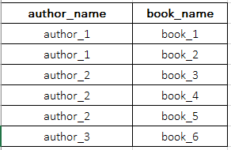

**BOOKS**

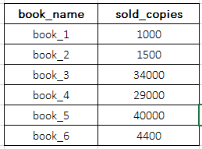

|  |  |
| --- | --- |
| 1. **TWO NUMBER SUM:**  * Write a function that takes in a non-empty array of distinct integers and an integer representing a target sum. If any two numbers in the input array sum up to the target sum, the function should return them in an array, in any order. If no to numbers sum up to the target sum, the function should return an empty array. * Note that the target sum has to be obtained by summing two different integers in the array. You cannot add a single integer to itself in order to obtain the target sum. * You can assume that there will be at most one pair of numbers summing up to the target sum.   **Sample Input:** numbers = [3, 5, -4 ,8, 11, 1, -1, 6] target_sum = 10  **Sample Output:** [-1, 11] the numbers can be in any order, it does not matter.  In assessment_2.py file | **22 points** |